503IT Communication and Collaboration
Week 2 Session 1 - First 4 Hours Revised Student Activity
UX Concept Development, Game Research, Canvas Upgrade and Storyboard Upgrade
Module | 503IT | Class | Group E
Session | Week 2 Session 1 | Duration | First 4 hours
Important message for students
Today you are not only decorating the game. You are improving the player experience. You must decide what the user sees, how the user plays, what the background looks like, what icons/buttons/characters are used, how feedback is shown, and how the game helps the user learn cyber safety. You must upgrade last week’s Game Concept Canvas and Storyboard into a stronger UX-focused version.

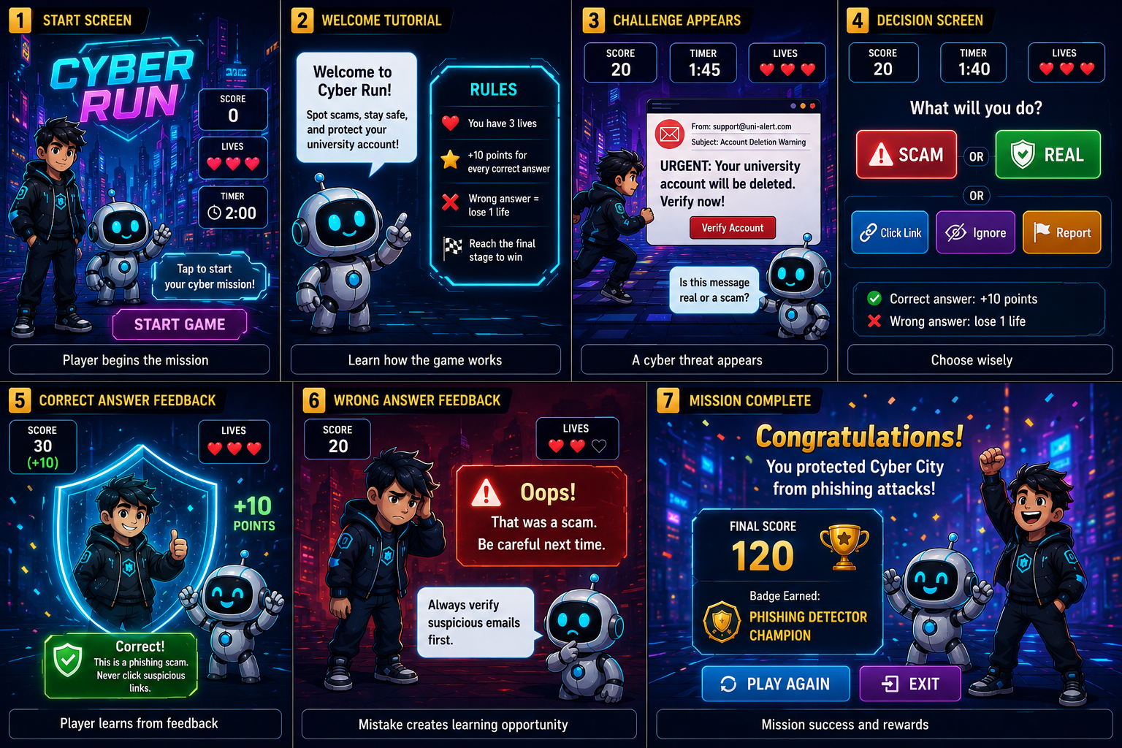
Sample visual direction: one UX-focused Game Concept Canvas and one -7frame storyboard for a 18-25 Year university student target audience.

2. Tools students must use today
Tool | Used for | How students should use it | Final evidence
GitHub | Evidence storage and contribution tracking | Hangma created Canvas concept & Vivek designed story board. Swastika merged into a power point file & uploaded into Github | .pptx  Canvas design (pdf)  Story board design
Canva | Preferred tool for visual design | Hangma upgraded the Game Concept Canvas and Storyboard using templates, icons, colour palettes, large text and visual layout. | PDF exports: updated-game-concept-canvas.pdf and updated-storyboard.pdf
PowerPoint | Backup visual design tool | Swastika created the slides, shapes, icons and text boxes.. | .pptx
Web browser | Research existing games/apps | We found 2 existing child-friendly educational games, such as Subway surfer & Temple run and identified how they attract and hold users. | game-ux-research.md
Worksheet / notes | Planning before final design | Discuss as a group and fill in the tables before producing final Canva/PowerPoint artefacts. | Completed written evidence and individual contribution logs

3. What they are upgrading from last week
Last week, students created the first draft of their Game Concept Canvas and Storyboard. Today they must upgrade those drafts. They should not start from zero unless last week’s work is missing or too weak.
Last week’s draft | Today’s upgrade | What should improve
Game Concept Canvas | Final UX-focused Game Concept Canvas | Clearer target audience, stronger learning objective, detailed UX choices, accessibility choices, rewards and success measure
Storyboard / storytelling flow | Final 6-frame UX storyboard | Better screen flow, clearer player choices, better feedback, child-friendly visuals, icons, buttons and background
Initial game idea | Improved game concept notes | Evidence of what changed and why
Group discussion | Meeting 03 minutes and contribution logs | Evidence of collaboration, decisions and individual work

4. First 4-hour session plan
Time | Activity | What students do | Evidence to upload
0:00-0:20 | Project and GitHub check-in | Open last week’s GitHub repository, check Day 1 and Day 2 evidence, check canvas/storyboard availability. | No new file yet; tutor checks progress
0:20-0:45 | UX and accessibility briefing | Understand UX, accessibility, inclusive design, gameplay flow, feedback and child-friendly design. | Notes for later files
0:45-1:25 | Existing game UX research | Find and analyse 2 existing games/apps/learning tools to identify how they attract and hold users. | game-ux-research.md
1:25-2:05 | UX concept decisions | Decide game look, background, icons, characters, buttons, instructions, feedback, rewards and accessibility choices. | ux-accessibility-review.md
2:05-2:50 | Upgrade Game Concept Canvas | Use Canva/PowerPoint to upgrade last week’s canvas into a final UX-focused canvas. | updated-game-concept-canvas.pdf
2:50-3:30 | Upgrade Storyboard | Create a 6-frame storyboard showing exactly how the player starts, plays, chooses, receives feedback and learns. | updated-storyboard.pdf
3:30-3:50 | Presentation practice | Each member prepares a short explanation of one UX improvement. Group prepares a short progress update. | presentation-practice-reflection.md
3:50-4:00 | Final upload and checklist | Upload files, check commits, update contribution logs and complete checklist. | meeting-03-minutes.md and contribution logs

Step 2: Research existing games or learning apps before designing

Example game/app | Target user | Colours/background | Icons/buttons | How it holds attention | Feedback/reward system | What we will apply
SUBWAY SURFERS | Kids & students | Bright, vibrant colors with cartoon-style city/railway backgrounds; high contrast for visibility | simple touch controls; clear icons for hoverboards, coins, missions | Fast-paced endless runner, increasing speed, obstacles, and near-miss excitement | Coins, character unlocks, hoverboards, daily missions, mystery boxes | Use bright visuals, simple controls, clear progression rewards, and daily challenge system
TEMPLE RUN | Kids & students | Dark jungle/temple environment with earthy tones and atmospheric lighting | Minimal UI; swipe-based controls with simple icons for boosts and abilities | Constant pursuit mechanic (monster chase), increasing difficulty, reflex-based survival | Score multiplier, coins, character upgrades, power-ups, achievements | Use immersive environment, progressive difficulty, reflex-based gameplay, and upgrade-based rewards

Step 3: Decide the UX concept for your own game

UX decision area | What students must decide | Example for 10-year-old users
Visual style | What the game should look like overall. | Bright, friendly, cartoon-style cyber adventure inspired by Temple Run and Subway Surfers
Background | What background appears on screens. | Neon cyber city, digital world, and futuristic adventure map
Colours | What colours support readability and mood. | Blue for safety, green for correct answers, red/orange for danger, high contrast colours
Icons | What visual symbols help understanding. | Shield, warning sign, email, lock, trophy, stars, and badges
Characters | Whether a guide or avatar helps the player. | Cyber hero and friendly robot assistant guide the player
Buttons | How choices are shown. | Large glowing buttons with short text and simple icons
Instructions | How the player learns how to play. | 3–4 simple tutorial steps before the first cyber challenge
Feedback | What happens after each answer. | Correct/wrong message with sounds, points, and short cyber safety explanation

Question | Group answer | Improvement needed?
Is the game easy to understand for the target audience? | Yes, because its similar to subwaysurf. Easy to play | NO
What will the player see on the first screen? | “START” button to start the game | NO
Are the instructions clear before gameplay starts? | Yes, in the second frame we added tutorial that explains the rules, timer, score, and lives. | NO
Are the colours, fonts and buttons readable? | Yes | YES
What icons or characters will help the player understand? | 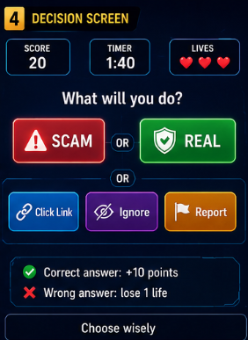 | NO
How will the game show correct or incorrect answers? | If it is correct, the character will gain the points & will continue the run.  If it is wrong the character will lose the live. 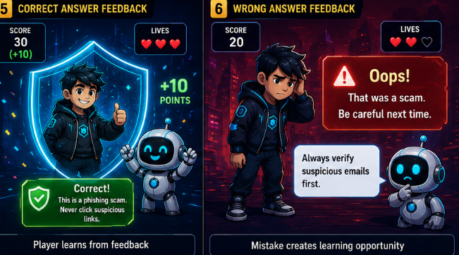 | NO
How will feedback teach the cyber-safety lesson? | The feedback was provided by “BITEBOT” with clear information | NO
How will the design support users with different learning needs? | simple navigation, bright visuals, and clear feedback that younger players understand quickly. | NO
What three UX/accessibility improvements will we make today? | We added larger buttons and clearer icons inspired by Subway Surfers so younger players can make choices quickly and easily.  Improve the game flow with simple tutorials and smoother screen transitions inspired by Temple Run to help players understand the game without teacher support.  Use brighter colours, higher contrast, and readable text to improve accessibility and make important warnings, rewards, and cyber-safety messages easier to notice. | NO
Commit message: Add UX and accessibility review

Required sections in the upgraded canvas
Canvas section | What to include | Quality expectation
Game title | CyberRun | Clear, memorable cyber-safety game name suitable for young players
Target audience | 18-25 year old University students | Specific age group with beginner-level cyber-safety knowledge
Cyber-safety topic | Phishing scams | Focused on helping players identify online threats
Learning objective | Players will learn how to recognize phishing scams and make safe online decisions | Measurable cyber-safety learning outcome
Game format | Endless runner style cyber adventure game inspired by Temple Run and Subway Surfers  The quiz will appear when character is running | Realistic and engaging game concept for the project
Core gameplay loop | Run through cyber challenges → identify scam or safe action → receive feedback → earn points and badges | Simple and repetitive gameplay that supports learning
UX design choices | Neon cyber backgrounds, large glowing buttons, shield and warning icons, cartoon hero and robot guide | Child-friendly design with strong visual guidance
Accessibility choices | Large text, high contrast colours, simple instructions, readable icons, positive feedback sounds | Easy for younger users to understand and interact with
Reward and motivation | Points, badges, extra lives, progress score, and congratulation screens | Encourages players to continue learning and playing
Success measure | Players correctly identify phishing messages and complete challenges with high scores | Shows players understand basic cyber-safety skills
Final file name: updated-game-concept-canvas.pdf
Upload location: Week-2-Session-1-UX-Accessibility/updated-game-concept-canvas.pdf
Commit message: Upload updated UX-focused game concept canvas

Step 5: Upgrade the Storyboard
The storyboard should show the player journey. It must show what the user sees and does from the start of the game to the learning outcome. It should not only describe the story; it should show the screen flow.
Frame | What to show | UX details to include | Example for 18-25 year-old target university students
1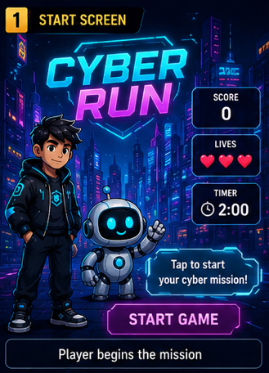 | Welcome/start screen | Game title, friendly guide/character, start button | Cyber Safety Quest with a Start Game button
2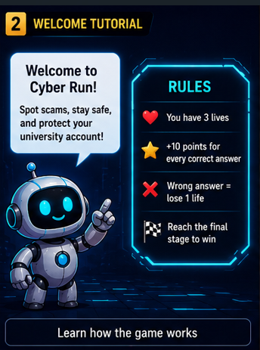 | Instructions | Short steps, icons, rules & clear action words | Read the instructions & challenge, choose the safest answer, get feedback, earn a star
3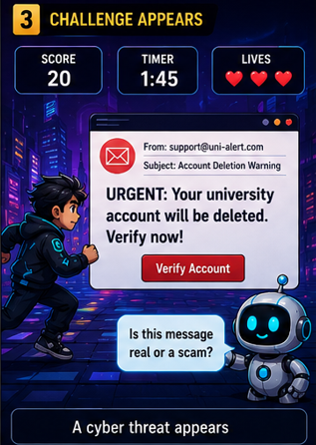 | First challenge | Cyber-safety scenario, background, message or problem | URGENT: Your university account will be deleted verify now!
4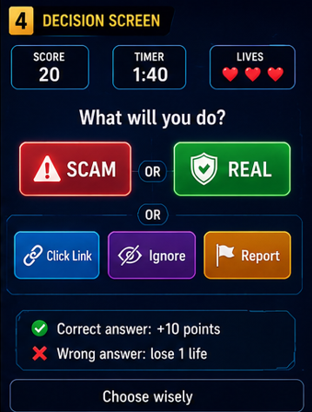 | Player choice | Large answer buttons, clear options, no confusing text | Click it / Ignore it / Ask a trusted adult
5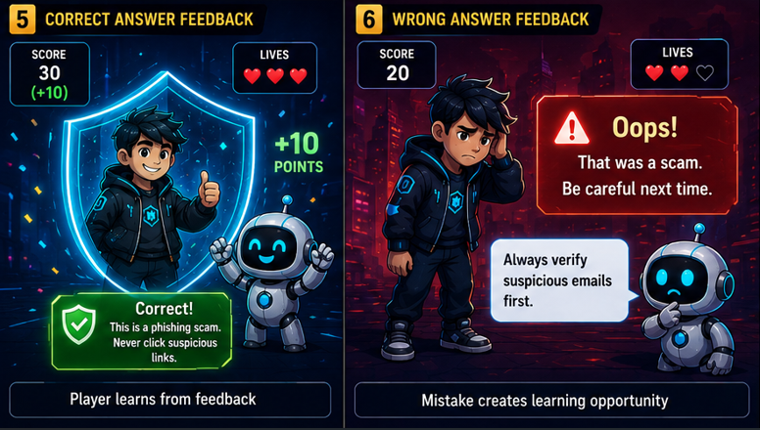 | Feedback | Correct/incorrect response plus learning explanation | Correct: suspicious links can be unsafe  Incorrect: Loss of live & feedback from BYTEBOT
6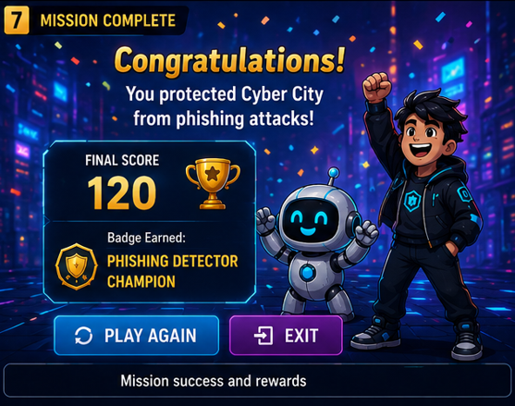 | Reward/learning summary | Score, badge, star or key lesson summary | You earned a Cyber Safety Star and learned about phishing scams.
Final file name: Story Board Week 2.png
Upload location: Week-2-Session-1-UX-Accessibility/updated-storyboard.pdf
Commit message: Upload updated UX storyboard

Step 6: Explain what changed and why
Students must create a written explanation of the improvements. This prevents the work from becoming only visual design. The group must show critical thinking.+
File path: Week-2-Session-1-UX-Accessibility/improved-game-concept-notes.md
Area | Original idea | Improved idea | Reason for improvement
Instructions | Basic text instructions | Simple step-by-step tutorial with icons | Helps younger players understand the game faster
Visual style/background | Plain cyber background | Bright neon cyber city inspired by Temple Run and Subway Surfers | Makes the game more exciting and engaging
Icons/buttons | Small basic buttons | Large glowing buttons with clear cyber icons | Easier for children to see and click
Feedback system | Only correct or wrong message | colors, points, and short explanations | Gives better learning feedback and motivation
Accessibility | Normal text and colors | Large text, high contrast colors, and simple language | Improves readability and accessibility
Reward system | Basic score counter | Badges, stars, progress bar, and level rewards | Keeps players motivated to continue playing
Commit message: Add improved game concept notes

6. What must be uploaded to GitHub by the end of the first 4 hours
Task | Evidence to show | Done? (Y/N) | Group member responsible
Create today’s folder | Week-2-Session-1-UX-Accessibility/ | Y
Research existing games/apps | game-ux-research.md | Y
Review UX and accessibility | ux-accessibility-review.md | Y
Explain improvements | improved-game-concept-notes.md | Y
Upload final canvas | updated-game-concept-canvas.pdf | Y
Upload final storyboard | updated-storyboard.pdf | Y
Record meeting evidence | meeting-03-minutes.md | Y
Practise speaking | presentation-practice-reflection.md | Y
Update individual evidence | Individual-Contribution-Logs/student-name-contribution.md | Y

8. Completion checklist with group member details
Complete this checklist before the end of the first 4-hour session. Every student must have a visible contribution.
Student name | Student ID | GitHub username | Main task completed today | Commit message | Signature
Vivek Thapa | 15845159 | Vivek-424 | Story board
Swastika Sundas Suyal | 15728966 | Syanasyana170-sys | Powerpoint
Hangma Limbu | 15209959 | Hangma16 | Canvas concept
Arbaaz Ul Haq Qureshi | 16200513 | arbaazulhaqqqsfj-web | Research UX apps
Hadshen Thavaseelan | 16247806 | Hads44 | Report completion

Group task completion checklist
Task | Evidence to show | Done? (Y/N) | Group member responsible
GitHub repository opened and checked | Group can show the repository | Y
Week-2-Session-1 folder created | Folder exists in GitHub | Y
At least 2 existing games/apps researched | game-ux-research.md completed | Y
UX and accessibility review completed | ux-accessibility-review.md completed | Y
Game look/background/icons/buttons/characters decided | Written in review or concept notes | Y
Last week’s canvas upgraded | updated-game-concept-canvas.pdf uploaded | Y
Last week’s storyboard upgraded | updated-storyboard.pdf uploaded | Y
Improvement explanation completed | improved-game-concept-notes.md completed | Y
Meeting 03 minutes uploaded | meeting-03-minutes.md uploaded | Y
Presentation practice reflection uploaded | presentation-practice-reflection.md uploaded | Y
Every student updated contribution log | Individual contribution files updated | Y
Every student has at least one visible commit | Commit history shows all members | Y

